7
Day 1 | Day 2 | Day 3 | Day 4 | Day 5
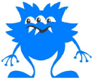  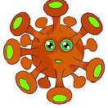    yab  wap  jix  krom  chip  mill  deep  gram | tass  beeg  theeb  ict  swoop  brass  rots  reefs | blorg  sposs  quast  vords  too  code  grime  steps | 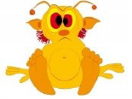  gair  fode  brime  smods  strap  seated  count  crowds | 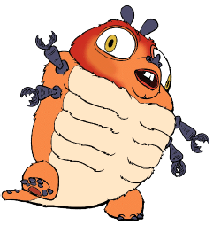  shroff  sprent  zerd  cowst  dairy  detail  tickling  footprint

