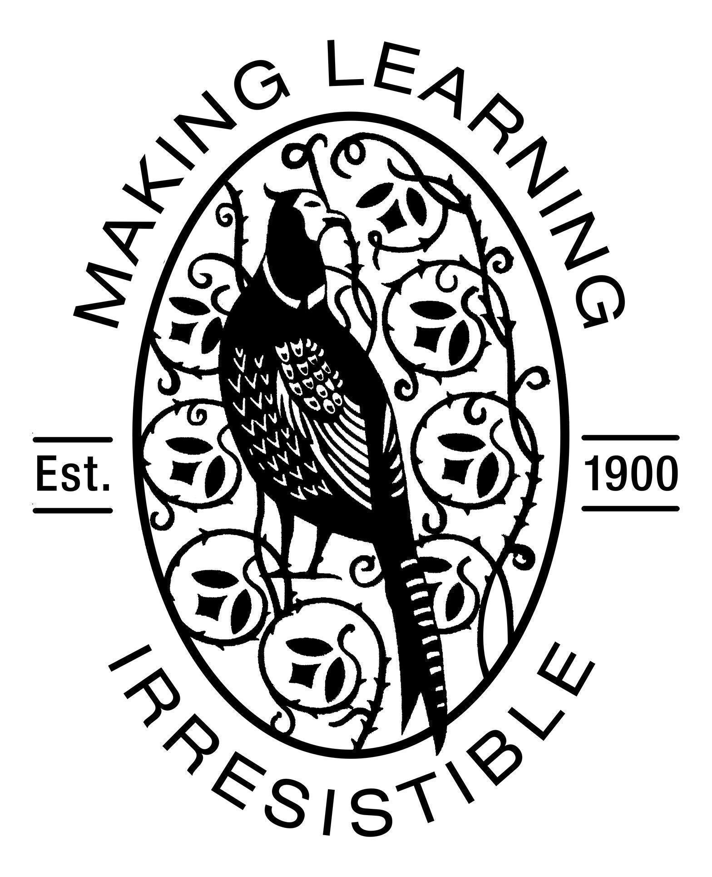

Morley Memorial Primary School
Curriculum Statement

Name | Curriculum Statement
Frequency of Review | Every two years
Reviewed: | June 2021
Reviewed by: | K Kowalska
Next review (date) | June 2023

UN Convention on the Rights of the Child 1990
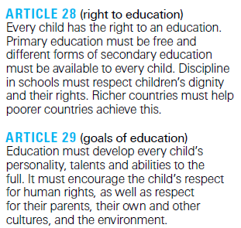

- Purpose and Intent

This statement sets out how, at Morley Memorial Primary School, we aim to provide a curriculum that makes learning irresistible to all children in our school which enables independent, resilient and motivated learners.

- Vision and Values

At Morley Memorial, we aim to provide a curriculum that stretches and rewards all learners. Our curriculum reflects our values of: learning, creativity, inclusiveness, respect, relationships and community. Our aim is that our curriculum meets the needs and then extends the horizons of our school community.

- Statutory Requirements

Our curriculum meets the requirements of the National Curriculum (2014) and other aspects of the school curriculum, including PHSE, Citizenship and The Agreed Syllabus for Religious Education.

- Equality

We keep our curriculum under review so that it continues to reflect our commitment to the 9 guiding principles outlined in our Equality Policy:

- All learners are of equal value
- Recognising and respecting difference
- Fostering positive attitudes, relationships, a shared sense of cohesion and belonging
- Observing good equalities practice in staff recruitment, retention and development
- Reducing and removing inequalities and barriers to equality that already exist
- Consulting and involving widely
- That society as a whole should benefit
- Basing practices on sound evidence
- Upholding our equality objectives

See Equality Policy

- Overview

Our intent is that ongoing curriculum development ensures that the school curriculum delivers the National Curriculum effectively and provides a vehicle for the school vision, values and ethos as well as for children’s personal and social development. Through a thematic, topic-based curriculum we aim to provide a relevant, inspirational and engaging curriculum which, where possible, incorporates experiential learning, so that children have the best opportunities to be creative, independent and resilient learners.

- Visible Learning

At Morley, we have been implementing the ‘Visible Learning’ programme since 2018. This programme of professional development is based upon research undertaken by leading academic, Professor John Hattie, to understand what leads to the most successful learning. The key tenet of the programme is that learning is most effective when teachers ‘see learning through the eyes of their students’ and equip children with the skills to ‘become their own teachers.’

Our learning dispositions are the habits of thinking we need to develop in order to be good learners. These habits shape how we think and respond in certain situations. They can be nurtured and they can change over time. They also affect the experience of each learner and those around them.

At Morley, we have six key learning dispositions:
- reflection - being able to learn from what has happened before
- collaboration - being able to work together
- resilience - being able to keep trying when learning is hard
- curiosity - being keen to learn and find out more
- courage - being bold and brave
- motivation - wanting to work hard to do a good job

In the Summer term 2021, we began to nominate some Learning Ambassadors. These children act as role-models to others; they have been chosen because they are great at demonstrating one of our key learning dispositions. When someone is elected to be a Learning Ambassador, they wear a special badge for a half term and they select a book to share with their class (one of our old favourites, a new story or a non-fiction text with a real life example of their chosen disposition). These ambassadors also take responsibility for explaining our dispositions to visitors. These pupils are not necessarily our highest attaining pupils but are those who have ably demonstrated the dispositions that lead to great learning and progress.

- Curriculum Structure

Our curriculum has the following structure:
- Half termly (approximately) cross curricular topics for all year groups.
- Each topic is led by a key subject or subjects with most subjects taught every half term.
- The combination of topics planned over a year and phase (Yrs 1-2, Yrs 3-4 and Yrs 5-6) ensures coverage of the statutory programme of study for the National Curriculum (2014)

Whole school topic map:
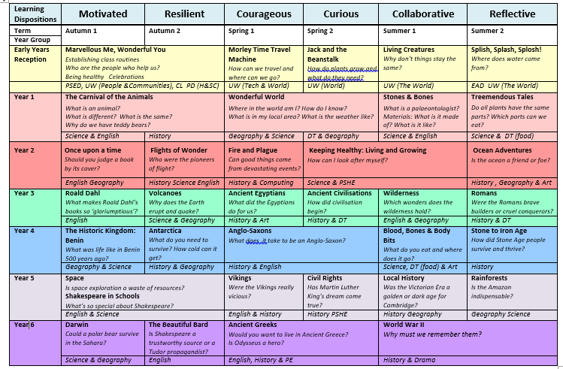

Each year group provides:

- Long Term annual planning which provides an overview of units of work for each subject. This is published
on the year group pages of the school website and updated in the Autumn term.

For example: Long Term Plan for Year One
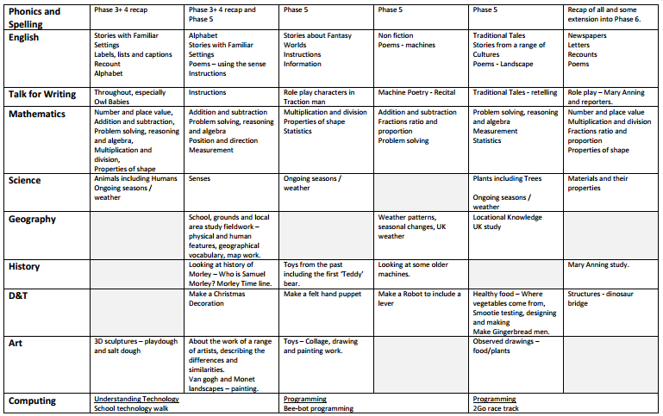
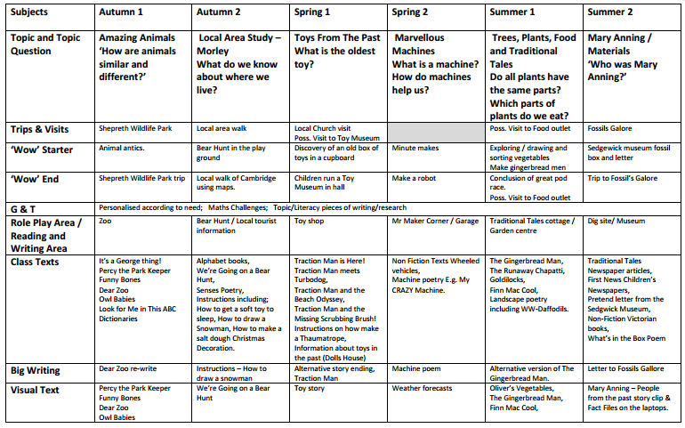

- Half Termly Topic Overview: which provides a more detailed map of the subjects taught in that half term,
with an outline of the main objectives planned and the key texts used.

For example, part of Half Termly Overview for Year Five:
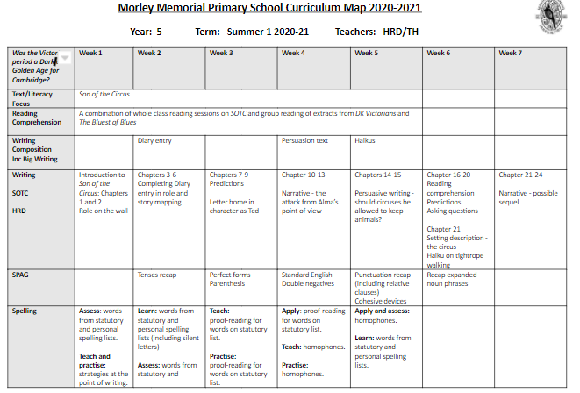

- Mid-term topic plans: which are detailed plans for the main subjects being taught within a topic, these provide detailed learning objectives, learning tasks and activities, notes on differentiation and assessment.

- Weekly plans are made for English, including Phonics and Spelling, and Mathematics.

See separate Teaching & Learning and Assessment Policies, and Section 9 on Planning below.

- Subjects

As core subjects, English and Mathematics are taught discretely, with links made to the current topic where relevant and meaningful. Similarly, Science is taught as part of a topic whenever possible, otherwise it is taught discretely. English and Maths are planned for weekly in response to ongoing teacher assessment and the requirements of the National Curriculum.

Subject Leaders provide a supportive role for all colleagues, enabling and ensuring coverage, progression and the development of their subject for the whole school. Subject leaders monitor and evaluate standards in their subjects, providing PD where needed. Subject Leaders provide detailed curriculum maps for their subject in the form of a whole school overview which includes all year groups, and a more detailed curriculum subject map for each year group.

The Core Curriculum

English Curriculum

Reading

Nurturing the ability and desire to read is one of the most important goals of our curriculum. Alongside the other components of our English curriculum we aim for our reading curriculum to equip all children with the skills to become effective readers but also to offer the opportunity for personal growth through the development of oral language, composition and even performance. In addition our reading curriculum encourages children to read widely and apply their reading skills across the curriculum.

Across the school we enable children to develop a passion for reading as well as the skills to do so by ensuring access to the highest quality texts. Planning around such high quality texts support readers of all ages and stages but also ensures we are providing depth and challenge and encompass a range of genres. Lessons are carefully structured to ensure that children develop the phonemic awareness to be able to decode words alongside developing their vocabulary, fluency and comprehension.

In the Foundation Stage children begin their reading journey by joining in with predictable phrases, using their phonic skills, reading and reciting rhymes, retelling familiar stories and traditional tales using actions and drama. These opportunities as well as being good fun, develop self-confidence, creativity and the ability to work with others. All children, from Reception to Year 6 take part in a group guided reading session once a week based on the reading objectives of the EYFS and the National Curriculum. Planning for reading is based around a quality text, often linked to a topic, and teachers use planning guidance from the Centre for Literacy in Primary Education to teach key reading skills.

Children in KS1 also take part in independent reading and spelling based activities daily to provide them with the opportunity to apply and reinforce their current phonics and guided reading teaching. All children have access to high quality home reading books appropriate to their reading level. We encourage daily home reading and communicate with parents using a shared reading diary. Many English and topic lessons start by exploring a range of texts to include stories, poetry, non-fiction and digital media. Through these texts children develop a love and purpose for reading. Through these opportunities NC reading objectives are highlighted, taught and reinforced.

Reading Assessment
Progress in reading is assessed responsively as children read to individually or in guided reading groups. Teachers keep guided reading assessment notes based on the National Curriculum requirements and use these to plan their teaching input. In Key Stage 1 running records (miscue analyses) are used, usually termly, to track progress and inform next steps for the teaching of reading. These are also used in Key Stage 2 should such detailed assessment be of benefit to the child. Where there are concerns about a child’s progress further individual assessments will be carried out to determine a child’s specific learning needs and provide information for possible further intervention. Termly teacher assessments including statements and steps are recorded termly using Target Tracker software. The school uses NFER tests for Years 2-6 in the Autumn and Summer terms which not only give a national standardised score but allow gaps in learning to be identified. At the end of the school year, children in Year 2 and Year 6 are assessed by their teachers against the national frameworks. They also complete SATs papers in May. The progress of children in EYFS is tracked using the Reception Baseline Assessment initially, formatively throughout the Reception year and at the end of the year using the Early Years Foundation Stage profile, which tracks pupils’ progress against the Early Learning Goals.

Phonics
Children are supported in developing their reading skills through the use of phonics-based books which are book-banded to provide appropriate differentiation and to support children’s progression and acquisition of key reading skills. Daily Phonics sessions are conducted in Reception and Key Stage 1. During phonics sessions children are taught to read and spell high frequency words alongside words that contain phonic patterns. Children then practice these words and learn to apply them in the context of a sentence. At Morley we strive to make phonics sessions systematic but also fun, creative and accessible to our kinaesthetic, visual and auditory learners. We make use of the Letters and Sounds phonics principles supplemented by the Floppy Phonics (ORT) programme to support planning and delivery. We plan activities with the interests of our class at the heart and also dip into games and activities from Phonics Play and Teach Your Monster to Read.

Phonics Assessment
Phonics teaching progression follows phases 1 through 6 from reception to Year 2. Phase 1 underpins the concept of oral blending and segmenting and is carried out through the year in reception.
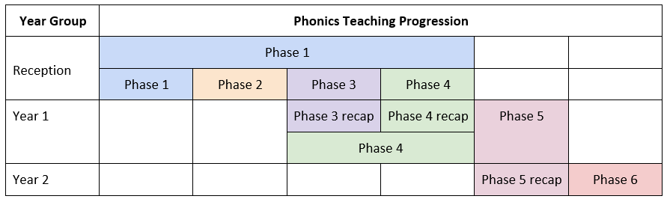

Children’s phonic progress is assessed regularly: termly and at the end of each phase. Assessments include phonic sound screening, reading high-frequency word screening, reading running records and spelling assessments with No Nonsense Spelling. Those children who may be falling behind their classes’ phonics phase follow targeted interventions in order to accelerate their progress. Interventions are tailored to the needs of the children and may range from phonics games, use of online resources (e.g. Cambugs and Teach Your Monster to Read) to systematically reviewing the letter sounds. Children in Year 1 undertake the national Phonics Screening Check in the Summer term. Any children who are not working at the expected standard are supported in Year 2 in order to help them successfully meet the expected standard. They undertake the phonics screening again at the end of Year 2.

Writing
At Morley Memorial Primary School, our goal is to ensure that all pupils become clear, confident communicators. We aim to equip our young people with the strong command of the spoken and written word that will allow them to thrive in their school careers and beyond so that they can fully participate in society. Our writing curriculum places high quality texts at the heart of several of our topics so that children are exposed to ambitious models for their own writing.

Our intention is that all children will develop the ability to write clearly, accurately and coherently, adapting their language to suit the purpose and audience for their writing. As such, our youngest children are encouraged to write in a variety of genres (including lists, letters, invitations and stories) and children progress to writing for an increasing range of purposes and audiences as they continue to develop their writing skills throughout Key Stage 1 and 2. By the end of Key Stage 2, they will have used a wide variety of writing experiences to become fluent, confident writers who understand and use a variety of writing forms, attending carefully to the purpose and audience of their writing. Where appropriate throughout their school career, children will write for a real purpose and audience: whether that is writing letters to charities or government organisations to bring about change or writing to entertain or inform their ‘buddy’ classes.

Children will be taught grammatical content appropriate to their year group in order to improve the accuracy and the impact of their writing; these grammar lessons will be wed to the purpose of the type of text being studied. Our intention is that all children demonstrate the ambition and motivation to produce high quality writing in terms of both composition and transcription. All classes display the expected grammatical content from previous year groups in order to communicate our high expectations for the accuracy of their written work. Where necessary, children will receive targeted support to address any misconceptions evident in their writing either through feedback from teachers and peers or through a targeted intervention programme.

High quality talk is evident in all of our writing lessons: “Writing floats on a sea of talk.” (Britton, J 1971 Language and Learning, University of Miami Press). We teach speaking and listening skills from the very first day in our Early Years classes and constantly build on these important skills as they develop throughout Key Stage 1 and 2. Rich, ambitious drama opportunities form a part of our writing curriculum (including, for instance, participation in the Coram Shakespeare Schools Foundation in Year 5). Children of all ages are encouraged to participate in high quality debates and discussions and our emphasis on collaborative learning (as part of our work on learning dispositions) means that children are regularly required to use discussion with peers in order to develop their thinking and must clearly explain their ideas to others. Older pupils in Key Stage 2 are also taught to make formal presentations and engage in ‘reciprocal teaching’, adopting particular roles in speaking, listening and reading activities. This engagement lays strong foundations for increasingly sophisticated spoken and written communication as well as promoting confident and considerate interactions between learners.

In Early Years and Years 1 and 2, children are taught spelling using a systematic phonics programme (see above). From Year 2, we follow the ‘No Nonsense Spelling’ programme, which teaches spelling strategies. We assess spellings in context, for example learning spellings in a given sentence, generating sentences for each word or assessing through unseen, dictated sentences. We also make use of paired and collaborative testing in order to focus on transferrable spelling strategies. We keep an ongoing record of words learnt and set very high expectations of correct application in writing once a word has been learned. All children are taught to write using a joined writing style from the middle of Year 1, using the Penpals handwriting scheme. In Years 1and 2, handwriting patterns from Penpals are given for practice at home. We encourage children to take pride in the presentation of their work .

Writing Assessment
Progress in writing is assessed regularly on completion of longer writing units. Children receive whole class and personalised feedback (which may be written or verbal) to identify their strengths and the next steps for their writing. Formative assessments are updated termly and take into consideration the grammatical accuracy and proficiency with transcriptional aspects of writing, as well as the effectiveness of the pupils’ composition. Teacher assessments are recorded on Target Tracker software half termly. Teachers use these assessments to identify areas for development which are then addressed in lesson planning (as well as in planning for interventions where necessary). At Morley, we also carry out a half termly piece of extended writing which is the same for all year groups. This allows teachers to obtain a ‘snapshot’ of children’s capabilities in an independent piece of writing. Teachers use a rubric to identify aspects of the writing that have been successful and areas which may require additional input. Having all classes complete the same task allows teachers to compare and moderate judgements to ensure robust assessment takes place. At the end of the school year, children in Year 2 and Year 6 are assessed by their teachers against national frameworks. The progress of children in EYFS is tracked using the Reception Baseline Assessment initially, formatively throughout the Reception year and at the end of the year using the Early Years Foundation Stage profile, which tracks pupils’ progress against the Early Learning Goals.

Mathematics Curriculum
It is our intention that all children will be capable mathematicians and our long-term goal for maths teaching is that it inspires a love for the subject and leads to a depth of understanding. At Morley we believe that everyone is able to learn and succeed in mathematics and children are encouraged to develop positive mathematical mindsets. We follow the NCETM teaching for mastery approach, which allows children to acquire a deep, long-term secure and adaptable understanding of the subject.

The National Curriculum is divided into units and teachers make conscientious choices about the learning journey through each unit. The carefully sequenced journey has a sense of coherence and includes: identifying the new mathematics that is being taught, what the main teaching points are, what the difficulty points may be, which representations are best to draw out the structure of the maths, key mathematical vocabulary and stem sentences and language. Units include opportunities for reasoning, problem solving and investigations.

“...Pupils and learners won’t benefit from racing through subjects at pace - so that everything is covered to some degree, but little is covered well…” (Amanda Spielman, 17 March 2021). Following the pandemic, for the 2021-22 year we are using the DfE ‘ready to progress’ criteria alongside guidance from the NCETM to prioritise the curriculum - taking into account curriculum coverage to date and disruptions to teaching and learning.

Children are taught through whole-class teaching with the focus being on all pupils working together on the same content and at the same time to ensure that these can be mastered before moving to the next part of the curriculum sequence. This is particularly helpful to those children who take a little longer to grasp new concepts – historically these children have made less progress in mathematics and we aim to address this through teaching for mastery. Children who are quick to grasp new concepts are encouraged to think more deeply about them rather than moving onto the next stage in the sequence.

There are two daily maths lessons. A shorter, 15 minute, lesson with a focus on factual and conceptual fluency which enables children to develop the skills of efficiency, accuracy and flexibility and a longer, 45 minute lesson that teaches new learning.

Mathematics Assessment
Progress is assessed throughout each unit and the learning journey is structured to give flexibility. This allows teachers to respond to children’s understanding as the journey is navigated. Termly teacher assessments including statements and steps are recorded termly using Target Tracker software. The school uses NFER tests for Years 2-6 in the Autumn and Summer terms which not only give a national standardised score but allow gaps in learning to be identified. At the end of the school year, children in Year 2 and Year 6 are assessed by their teachers against the national frameworks. They also complete SATs papers in May. Where there are concerns about a child’s progress further individual assessments will be carried out to determine a child’s specific learning needs and provide information for possible further intervention. The progress of children in EYFS is tracked using the Reception Baseline Assessment initially, formatively throughout the Reception year and at the end of the year using the Early Years Foundation Stage profile, which tracks pupils’ progress against the Early Learning Goals.

Science Curriculum
Science, as a core subject, is taught as part of our creative curriculum and is the subject driver for many topics. We follow the National Curriculum objectives which teachers break down into the half-termly overview. Practical, engaging and hands-on science is embedded throughout all year groups with a focus on developing the children’s working scientifically skills as well as their subject knowledge. Child-led enquiry in science lessons is our long-term goal and a focus for our Science Action Plan. Where relevant we plan investigation days so ensure that children can be fully immersed in the investigation and have the time to test their hypotheses. In addition to weekly Science lessons we aim to deliver a daily 10 minute Science input, for example using a microscope and the interactive whiteboard to look at an object in detail, or asking children to select the ‘odd one out’ and give their reasons. This daily input helps ensure that Science remains prominent and is identified as being in everything we do.
At Morley we know we have many families who are connected with the wider scientific world. We harness these valuable links by inviting parents and others to take part in our Science events, including our biennial Science Week, as well as helping to enrich the taught curriculum. Year 6 also take part in real-life university research projects through the BBC’s Terrific Scientific which builds engagement and helps the students to find out about how experiments inform research.

Science Assessment
Teachers make use of Rising Stars Assessment Tests – a baseline test is undertaken to assess prior knowledge of the class and help plan lessons and an end of topic assessment is undertaken once all the content has been taught. Teachers also update steps in Target Tracker when a Science unit has been taught. This, then, builds up a picture of the children’s knowledge throughout their school career and is an invaluable tool to help assess end of key stage science achievement.

Physical Education (PE)
PE is, by its very nature, a practical subject and its teaching at Morley reflects this: we aim to have children moving and participating most of the time. Each class has two PE sessions planned per week, one indoor and one outdoor; both lessons last between 45 minutes and an hour (due to timetable allowances). These lessons are planned and delivered by the class teacher using the Cambridgeshire Scheme of Work as a starting point but also using a variety of published resources for further ideas and inspiration, according to the needs and skills of the children in the class. In recent years we have welcomed outside coaches (from, for example, Cambridge United or the ECB’s Chance To Shine Programme) both as a means of improving children’s skills and of providing CPD for teachers. Children have the opportunity to take part in ‘Enrichment Weeks’ provided by Premier Sports, these are usually focused around athletics or sporting disciplines which the children do not have access to as part of their curriculum based PE lessons (archery, blindfold football being some recent examples). In addition to this, children in Years 3, 4 and 5 have one term of swimming lessons per year (approximately ten 30-minute sessions) taken by qualified swimming instructors. This meets the requirements of the National Curriculum so that children can “swim competently, confidently and proficiently over a distance of at least 25 metres… [using] a range of strokes effectively.” Children who are not actively participating in the lesson for whatever reason are asked to take on the role of evaluators or helpers rather than reading or completing work so that they also develop their understanding of the lesson. Staff have access to assessment criteria from the Cambridgeshire scheme of work as well as a Morley exclusive rubric derived from the ‘Weaving Knowledge & Skills’ documentation.

In Key Stage 1, children are expected to “develop fundamental movement skills, become increasingly competent and confident and … extend their agility, balance and coordination”. Gymnastic lessons use a variety of equipment (mats, benches, tables) to develop these skills and put them together into sequences; dance lessons also focus on developing these skills. Games lessons, especially in Early Years and Year 1, are often based on generic skills such as balancing, jumping, throwing and catching rather than specific sports.
Dance and Gymnastic lessons continue to “develop the flexibility, strength, technique, control and balance” of the children in Key Stage 2, applying these to increasingly difficult sequences and movements. Games lessons become more sport specific throughout the Key Stage, but still aim to develop the skills which will enable the children to play each sport competitively rather than simply play a series of games. They also “take part in outdoor and adventurous activity challenges” such as orienteering and team building activities. As a city school we are aware of the limited space available for outdoor PE, and aim to give children as many opportunities for physical development as possible. With this in mind, we make full use of nearby facilities at the Coleridge site of the Parkside Federation, where we hold our annual sports day and regularly participate in Multi-skills sports festivals as well as other sporting competitions. We are currently subscribed to the Cambridge School Sports Partnership (based at Netherhall) and the Coleridge Sports Partnership, giving us access to a wide variety of different sporting events. Physical activity is not restricted to PE lessons, and we have a busy programme of playtime activities led by Premier Sport, and are participating in the Young Sports Leaders programme. Premier Sports also run a number of additional after school clubs including (but not restricted to) boys and girls football. Our PE curriculum is accessible to all and aimed at enabling all learners to participate and succeed in the subject, regardless of starting points.

Humanities
Through the humanities subjects we learn about the narrative of human existence, physically and spiritually. The foundation subjects of history and geography provide children with a vital pathway to learning about the world around them and their place within it. These subjects are integrated into the topics, and form the basis of most cross- curricular links.

History
History is an important subject in topic-based learning at Morley Memorial, with each unit providing opportunities for children to become independent and resilient learners. Teachers use the National Curriculum and the Weaving Knowledge and Skills document to ensure children have a secure chronological understanding of their topic in addition to practising key skills of enquiry by hypothesising, collecting and analysing evidence and making well-informed judgements. We build links with external groups that provide a range of artefacts and primary evidence for use in the classroom, such as the University of Cambridge Museums. Children are given meaningful opportunities to experience History beyond the classroom, including visits to museums, historical sites such as Anglo-Saxon villages, and welcoming external specialists into school. ‘Wow Days’ are used at the beginning of a term to fully immerse children in their topics, including ‘A day in the life of an Egyptian’ in Year 3 and ‘A day in the life of an Ancient Greek’ in Year 6.
Learning environments play a key role in enhancing children’s historical skills and curiosity about their topics. Timelines are used in every classroom and displays encourage independent enquiry with the use of prompts, engaging questions and a range of appropriate resources which learners can access for independent research. A range of children’s work is displayed and celebrated throughout the school, often being cross-curricular in nature. This includes pieces of extended writing such as ‘Shakleton’s Expedition’ diaries in Year 4, as well as creative art projects such as Year 3’s canopic jars.

Teachers make use of the National Curriculum and the Weaving Knowledge and Skills document (Focus Education) to form the basis of their assessments and update steps in Target Tracker when a History unit has been taught.

Geography
Geography at Morley is embedded in the school’s topic based curriculum and all children in all year groups have access to well-planned and delivered geography across the four strands of the subject: location knowledge, place knowledge, human and physical geography and geographical skills and fieldwork. For example, United Kingdom location knowledge and human and physical geography are covered throughout the year in Year 1, woven into stories about weather and seasonal events from around the country. In Year 5, for example, these two strands are addressed through the Rainforest topic where pupils learn about latitude, longitude and biomes by learning about the forests of South America and comparing Brazil with the UK. In Year 3 children learn aspects of place knowledge and human and physical geography in Europe in the ‘Wilderness’ topic; the children study an environmental region in Poland and make comparisons with England. In Year 2 pupils begin to extend their mapping and fieldwork skills by looking at Ordnance Survey maps and making their own story maps. By Year 6 pupils are using six-figure grid references (GR) to identify human and physical differences between coastal Cromer and urban Cambridge, with the pupils using GR to navigate on their residential in Norfolk. Finally, fieldwork consists of walking the local area and identifying features in Year 1, progressing to more detailed fieldwork as children progress through the school.
Geography is assessed at the end of each topic on individual pupil’s topic overview sheets and is also recorded on Target Tracker in the term in which the topic is covered.

Religious Education (RE)
At Morley we follow the Cambridgeshire Agreed Syllabus for RE, updated in 2018. RE is an important statutory part of the curriculum. It is important in its own right and it also makes a unique contribution to the spiritual, moral, social and cultural development of pupils and supports wider community cohesion. Morley is a diverse community and as such, our curriculum represents a wide range of religious and non-religious beliefs.
Religious Education contributes to our core purpose of making learning irresistible to all the children at Morley and creating independent, resilient, motivated learners. Developing skills and attitudes that enable broad-minded interaction with others in a diverse world is an essential part of this process. Through tackling 'big questions,' children develop the critical thinking skills required to become independent learners and the listening skills necessary to engage responsively with the beliefs and ideas of others.
In Early Years, children find out about celebrations from different faiths practised by families in the Morley community and enjoy stories from different religions. In Key Stage 1, core units focus on the beliefs and practices of Sikhism and Christianity alongside multi-faith units on celebrations and special days. In Key Stage 2, children learn about all of the major faiths and other relevant life stances such as humanism. In all age groups, a variety of stories and artefacts are referred to, and meaningful links are made between major faiths as appropriate and in response to the range of faiths or other life stances reflected in the class.
Across the age-range, children are encouraged to develop their own beliefs and express them with increasing clarity. They also identify links between beliefs, values and practices from diverse cultures. Emphasis is placed on the need to learn about religion (to describe the beliefs and practices of major world faiths with accuracy and understanding) and from religion (developing the ability to evaluate ethical issues and express their own responses, using reasoned arguments).

Personal, Social and Health Education (PSHE) and Citizenship
PHSE and Citizenship are a key element of the social and emotional development of our children. We follow the Cambridgeshire Personal Development Programme on a biennial cycle to support our PSHE lessons. Where possible, units are delivered with a theme for the whole school for each half term, e.g. Personal Safety. The programme is used as a basis for planning which is then adapted by the teachers to meet the specific needs of the children in their class. The programme also provides access to resources and websites to support the children’s development. In addition to discrete PSHE sessions, assemblies often relate to aspects of the PSHE curriculum that affect a phase or whole school.
Particular focus is given to the prevention and response given to bullying during Anti-bullying Week.
Sex Education is delivered to all year groups on a two-year basis, in-line with the school’s Relationships and Sex Education Policy. For Reception, Years 5 and 6 they follow the Sex and Relationships Education unit every year.

Modern Foreign Languages
At Morley Memorial we aim to recognise and celebrate the diverse linguistic and cultural backgrounds of our learners. This is both within classes through the sharing of different languages of the week, and as a whole school through assemblies and displays. We have a selection of non–English language and bi-lingual texts in the school library as well as a growing collection of French language texts. Post Covid -19 restrictions we aim to strengthen our links with our wider community and welcome speakers of different languages into school to share their linguistic and cultural skills and knowledge with us.
In addition to celebrating the different mother tongue languages of our pupils, all Key Stage 2 learners participate in weekly French lessons. These lessons are generally delivered by a specialist French teacher, although class teachers also deliver lessons, as required. We have designed and created a curriculum based on the Key Stage 2 National Curriculum standards and objectives which allows the pupils to gradually build up their phonetic knowledge, vocabulary and grammar through a variety of topics. The focus is on developing confidence with pupils having frequent opportunities to speak aloud in a range of contexts, creating their own simple sentences and posing and responding to questions. Stories, songs and rhymes as well as links to other subject areas such as art and geography are all made to provide a rich and varied learning experience.

Computing
Computing is taught discretely where appropriate, while other elements are embedded within English, Mathematics and topic learning. Teachers are encouraged to develop children’s computing skills progressively and their capability through discrete learning opportunities, and also to exploit this capability as a tool to support objectives in other curriculum areas meaningfully. Lessons and homework utilise the Google ecosystem, including Google Classroom for homework tasks, to ensure consistent digital literacy practise to link together computing and the wider curriculum. These links include, but are not limited to, the use of digital devices in a wide range of contexts. Both plugged and unplugged learning opportunities are planned to support pupils’ understanding of the underlying concepts in Computing. These opportunities may well be presented within other subject areas (e.g. Google Docs collaborative writing projects in English, Jamboard problem solving in Maths or isolating variables in Science). In this way, Computing and the use of technology has become integrated into the curriculum and are used as a truly beneficial tool for learning.

Expressive Arts
Creativity is at the heart of learning, and as a school with a creative curriculum we place great emphasis on developing and extending children’s skills and abilities to respond creatively to a range of starting points. This is reflected throughout the curriculum, but especially in our expressive arts provision. We have joined Artsmark (first awarded in 2016-17) and our arts and cultural provision has achieved the Gold Artsmark standard.

Design and Technology
Design and Technology plays a huge part of our purpose of making learning irresistible to all the children at Morley. The subject equips children with problem solving skills such as working systematically, being resourceful, visualising, conjecturing, taking risks and using logical reasoning in real world contexts. It develops resilience because trial and improvement is woven into the iterative process. It is logical and practical. It fosters creativity and is an inherently cross-curricular subject, providing opportunity for English, Maths, computer skills and scientific knowledge to be practically and usefully applied by building a bridge between learning and its usefulness, relevance and application in the real world. It relies upon children being innovative and finding new ways of solving things. At Morley, children have opportunities to understand how things are made, to create and develop ideas and to design, make and evaluate products that solve problems. In doing so, they learn how to use tools and equipment and how to work with materials. We link with national initiatives such as Young Engineers in order to achieve this.
One project takes place per term per class. In Key Stage 1, these projects cover Mechanisms, Structures, Food and Textiles. In Key Stage 2, they cover Mechanical Systems, Electrical Systems, Structures, Food and Textiles. In DT teaching, we aim to take into consideration each of the principles of effective Design and Technology practise as set out by the Design and Technology Association (DATA), which are: design decisions, functionality, authenticity, innovation, purpose and user.
DT at Morley aims to sow the seeds of a passion and kick start an interest in anything that could illuminate a path ahead towards creative, engineering and manufacturing sectors. It aims to give fledgling engineers, designers and technologists an experience of how the world works; of how to think laterally and innovatively, and of how things are made.

Art and Design
Art and Design is a key subject in our creative curriculum, and equips children with skills in visualising, designing, adapting and evaluating. Art topics are expected to enhance, enrich and motivate children within the main topic of the term or half term. There is an art subject focus at least termly (alternating with Design and Technology), although there are often more opportunities for creative art-based work as part of other topics. We aim to provide children with a range of meaningful, and purposeful opportunities to find out about, learn and express themselves through the media of: drawing and painting, collage, 3D work and sculpture, textiles, printmaking, and digital media. Artwork is mainly carried out in sketchbooks, which provide a location for children to research, explore, create and evaluate ideas. Sketchbooks are also used to evidence skills-based progression: children are expected to have time to develop and experiment with key skills before producing a final piece. When children produce final pieces of work, we maintain a photographic record once work has been displayed and/or taken home.

We use a range of resources, including the Awesome Art resource (Chris Quigley) and the ‘Access Art’ website, to support teachers in planning and delivering exciting and inspirational learning opportunities. Children are also given access to wider experiences beyond the classroom, for example, gallery and museum visits, visiting artists, performances and performers. Certain groups of children identified as disadvantaged, are also given the opportunity to attend our ‘Brilliant Makers’ extra-curricular model-making club which focuses on providing children with access to extra resources and teaching input.

Teachers maintain a Creative Provision Map for their year group (indicating creative opportunities which take place each half term), which contributes to the ongoing improvement of the arts and cultural provision at Morley Memorial.

Assessment in Art is undertaken through teacher judgement. Making use of the National Curriculum programme of study, and the Weaving Knowledge and Skills document (Focus Education), teachers update steps in Target Tracker when there has been an Art unit taught.

In 2019 we achieved our first Gold Artsmark for our creative provision. We are now in the process continuing our Artsmark journey, and hope to achieve Gold or Platinum in 2023.

Music
At Morley Music is taught generally by a combination of specialist and class teachers. A proportion of our teaching follows Charanga – the Cambridgeshire Scheme of Work for music; however in all year groups, several topics are independently developed in order to cover other aspects of the Music curriculum. In addition, several Units have been planned by our specialist teacher in Years 5 & 6 to broaden the curriculum; including the “Sing for Our Schools” project which concentrates on group composition and recording. All children have access to class instrumental tuition; all Year 3s participate in class recorder lessons for a term (once COVID restrictions lift); and all Year 4s receive a term and a half’s ukulele teaching. In addition, all children in KS1 and KS2 will attend a weekly Singing Assembly (once COVID restrictions lift), aimed at developing skills and enjoyment in singing. Following the onset of Covid restrictions, the Music curriculum was adapted and re-written to enable it to continue to be an engaging educational experience, despite the very tight restrictions on singing, working in groups and the use of sets of instruments by only one year group at a time. During remote learning a dedicated music intrasite was created in order to continue access to weekly class lessons and virtual Singing Assemblies, choirs and KS2 Band. Regular musical challenges were set; and any virtual performance opportunities shared. During usual school operating conditions, children have access to music beyond the classroom through the KS1 and KS2 choirs and KS2 band; all of which are open to children of any ability and free to access. We act as host for teachers from Cambridgeshire Music instrument teaching, which parents are able to arrange directly. Opportunities for performing include: KS2 Christmas and Summer Concerts for choir and band; performing to a local community group; KS1 choir Summer Concert; Ukulele performances; the Year 3 and 4 biannual Productions; being part of the Young Voices Choir at the O2 Arena , the KS1 Winter Performance; the Summer Fair Talent Show; and the Year 6 Leavers’ Production and other performance opportunities that crop up on an ad hoc basis. All Year 6s are given the chance to audition for group or solo performances in the KS2 Summer concert.
Different year groups often share what they have been learning through Whole School or Key Stage assemblies or inter-and intra-class performances. We also aim to provide opportunities to see live performances from visiting professional musicians; to be accessed by all children.

Assessment in Music is undertaken through teacher judgement. Making use of the National Curriculum programme of study, and the Weaving Knowledge and Skills document (Focus Education); around 6 KPIs have been identified for assessment in each year group. An overall grading at the end of the year is based on these KPI assessments.

Outdoor Learning
At Morley we know that taking learning outdoors gives children a different perspective, can put learning into a real life context, can stimulate creativity and supports a holistic approach to pedagogy. Morley Memorial Primary School also recognises the importance of outdoor experiences to the wellbeing and physical and mental health of our community. Our aims with a focus on outdoor learning are twofold. Firstly, to encourage existing curriculum learning opportunities to be taken outside when this will augment the learning. This is particularly appropriate in Science, Geography, Art and English. The outdoor space is being developed to allow classes to be held outdoors and teachers are supported by the Outdoor Learning Lead with planning ideas and resources if needed.
Secondly, to give every child at Morley Memorial Primary school the opportunity to participate in Forest School during their time at the school. A Forest School pilot will be completed in Summer 2021. From this starting point, a whole school Forest School approach will be developed from September 2021. Assessment in outdoor learning will be linked to the subject area that is being taught outside. In Forest School, assessment is undertaken through observation and reflection by the Forest School Leader and other supporting adults. This is used to plan future sessions that build upon the children’s interests and needs and is fed back to class teachers to support in their planning and assessment.

Pupil Voice
At Morley we encourage and give opportunities for children to express their unique perspectives on what it is like to be a pupil at this school; involving them in decision-making can create meaningful change and better academic outcomes, as well as facilitating a sense of empowerment and inclusion.
Pupil voice at our school means a whole-school commitment to listening to the views, wishes and experiences of all children. It means placing value on what children tell school staff about their experiences.

Children are provided with meaningful opportunities to share their experiences, views and hopes about their school. At Morley we do this by carrying out annual behaviour surveys, using suggestion/worry boxes in class, having regular School Council meetings and within curriculum subjects where we encourage and expect children to give their opinions and express their views. Our School Council is led by Year 6 children who are trained to lead vertical group meetings which include children from Year 1 to Year 6 (during non-Bubble operating). Children discuss issues and give their feedback. The Year 6 teams will then share that feedback with the Head Teacher who is able to take account of children’s views.

Woven through the curriculum, pupil voice is always encouraged by the provision of the tools and experiences we provide to help children express themselves. This is seen particularly within the PSHE curriculum where we actively promote pupil voice within a safe arena. As part of our Visible Learning journey, we focus on the feedback children give us, through their words, their working outcomes and their deeds. This feedback is used to improve our teaching, outcomes for children and ensure school is a safe place to be. In daily school life, where a child shares negative experiences, we have robust processes for dealing with behaviour issues which places the child's lived experiences at the centre. Pupil voice is also an integral part of our usual expectations for social interaction between peers and adults and through our Safeguarding processes: children need to know that it is safe and important for them to express their views about what happens to them. They need to know that what they say is valued and will be listened to and considered. We want all children at Morley to know that they will be heard, and that their safety and learning outcomes are our prime concerns.

National Curriculum for all primary subjects:
https://www.gov.uk/government/publications/national-curriculum-in-england-primary-curriculum

- Time Allocation and Timetables

We organize the time spent on different subjects with the best possible learning outcomes for the children in mind. Where a subject is the focus of a topic, this will have more time allocated than other subjects. The core subjects remain at the centre of our curriculum, and so have more time allocated to them.

While class teachers are responsible for the day-to-day timetabling of the curriculum, subject leaders have responsibility to ensure coverage of their subjects, and the Curriculum Leader and Senior Leadership Team maintain an overview of the whole curriculum to ensure full coverage and balance of the curriculum.

- English and Maths are the main focus of the morning sessions.
- Some subjects will be taught discretely in weekly sessions e.g. PHSE, RE , Music, PE
- There will be regular basic skills sessions each day, including guided reading, handwriting, phonics, spelling.

Teachers are able to arrange timetables to make the most of cross-curricular opportunities and the needs of children. Sometimes subjects and activities might be ‘blocked’ to support children, maintain learning momentum, establish new concepts or to consolidate skills and to allow practical work to flow. Other subjects might be dependent on hall/room bookings or other practical considerations, and happen at a regular time each week.

- Topic Planning

We are responsive to children’s learning needs so all plans are amended and adapted and are considered to be working documents rather than a final plan that cannot be changed.

When planning, teachers are required to provide the following:
- Long term annual overview
- Half termly overview
- Medium term topic (subject) plans
- Topic assessment sheet which includes pre- and post-learning assessments
- Weekly plans for Maths and English including spelling, with a separate plan for phonics in EY/KS1, as appropriate
- Weekly timetable

Teachers are expected to refer to the National Curriculum, (or Agreed Syllabus for RE) when planning to ensure they are meeting statutory requirements. It is recognized that many of the objectives in the National Curriculum are quite general so it is to be expected that many are repeated over a year and/or phase. Teachers also use the Weaving Knowledge and Skills document which identifies key and challenge questions to assist with assessment alongside Target Tracker assessment statements to assist in planning for children’s learning needs and coverage. Where published schemes of work are in use, it is acceptable to amend the published scheme rather than re-write and create an entirely new plan. Our aim in planning and delivering the curriculum is for learning opportunities to be engaging, creative and motivating and which enable our children to become creative, resilient and independent learners. Planning is saved electronically in the shared network planning folder for each year group so that it is accessible for teaching, learning and monitoring.

Long Term Plan
This provides a brief outline of topics and coverage for the entire year, reviewed annually and published on the school website.

Half-termly Overview
This is a week by week outline of how learning objectives are organized over a half term for all subjects, indicating main, events, trips and visitors, and indicating which subjects are blocked. The half-termly overview supports teachers in planning a realistic amount of work to be covered and should be completed before the start of a half-termly topic.

Mid-term Topic & Subject Plans
Each topic is led by an overarching question, which gives shape to the expected learning, and provides a stimulus for thinking about the topic. Topics begin with a ‘Wow!’ starter, which may be in the form of an event, a day dedicated to engaging learners or a visit or visitor and which aims to inspire and inform the children at the beginning of the topic. Topics are often planned to include trips out or visitors into the school. These are used effectively to enhance the curriculum and provide opportunities to deepen and extend learning. We aim to develop and make use of creative partnerships with providers in the local community to motivate and engage learners, for example, Shakespeare in Schools, or History Works, which lead to significant performance experiences for the children.

The mid-term topic plan outlines the main unit of work for the half term topic. The first section of the mid-term plan includes:
- an overview of key themes
- the main curriculum focus and additional links to other subjects
- vocabulary to be used in teaching and learning
- key question for the entire topic
- trips, visits or other events
- how the learning environment will reflect the topic
- expected outcomes for children (referring to the National Curriculum)
- assessment questions (referring to Weaving Knowledge and Skills)
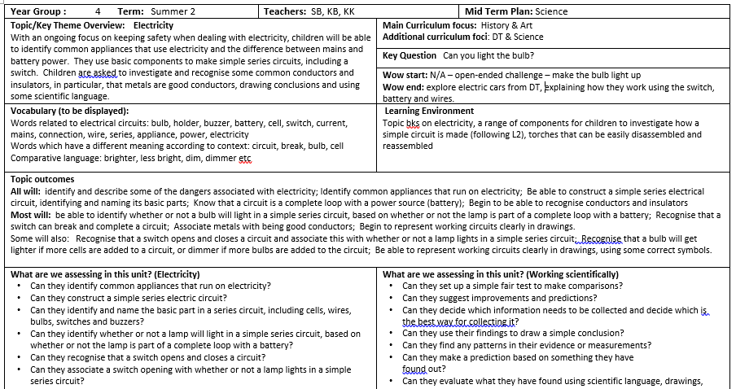

The second section is a session-by session outline of the unit of work which is detailed enough not to require further short-term planning. It includes:
- learning objective for the session (referring to National Curriculum)
- Key questions for assessment (referring to Weaving Knowledge and Skills)
- main teaching and learning activities
- indicates outcomes for children, success criteria and differentiation
- resources needed for each session, including use of IT and adult support where relevant

The final section is an assessment recording grid, where teachers are able to record whether or not children are achieving the learning objectives for each session. This section aims to support teachers in reminding them of children’s achievements in the topic when deciding whether or not children have met age-related expectations in the relevant subject. It has been agreed by teaching staff as part of whole school curriculum development.
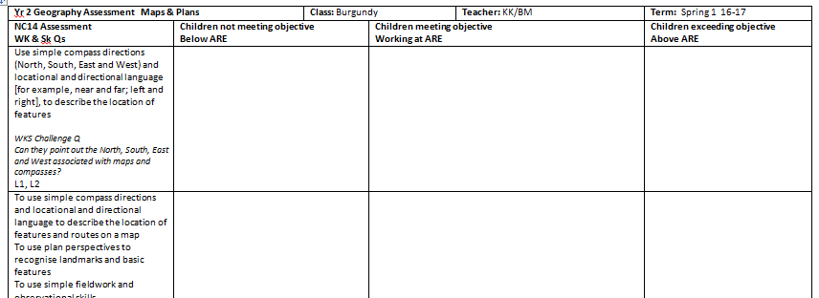

Topic Assessment Sheet
This is included in the relevant topic book for each child and consists of:
- cover with title, key question and subject focus along with an engaging picture
- topic overview taken from the mid- term plan
- pre- and post-learning assessment questions
- ‘I can’ assessment statements (linked to National Curriculum objectives and taken from Weaving Knowledge and Skills documents)

The purpose of the topic assessment sheet is:
- to provide teachers with information regarding children’s starting points at the beginning of the topic so they can adapt the emphasis of the topic teaching and learning sessions accordingly.
- to provide evidence of individual children’s progression in learning at the end of a topic
- to provide an individual record of whether or not children have achieved the learning outcomes referred to by the ‘I can’ statements within the relevant book where work has been recorded so that teachers are better able to make informed assessment judgements
- to provide a brief overview for parents when they look at their children’s work in the books
- to make clear the connection between assessment, teaching, learning, recorded outcomes, and further planning
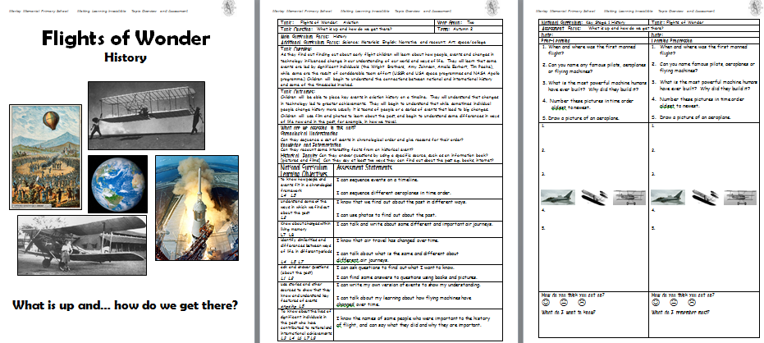

The pre- topic assessment is the first task to be completed at the start of a topic, before any other teaching and learning activities. While this will not be the only assessment for learning activities that take place in a topic, it provides a useful starting point for teachers to use when responding to children and adjusting teaching based on what the children already know. The post-learning assessment will take place at the end of the topic and gives an indication of individual progression. This enhances and contributes to, but does not replace other, more extended assessments which provide more detailed information.

See separate Teaching & Learning and Assessment Policies.

Weekly Plans
Teachers provide weekly plans for English and Maths and Phonics in Key Stage One and Early Years. These plans refer to the National Curriculum, include main learning objectives, teaching and learning activities, differentiation, success criteria and key questions for assessment.

Timetables
A generic timetable template is provided for each phase with required subjects mapped out weekly. Teachers are expected to provide an up-to-date weekly timetable. Where a foundation subject is not the focus for the topic in a particular half term, it is not expected to be on the timetable. It is acknowledged that there will be times when it is not possible to teach every session on the timetable and flexibility is required to give time to other events, to continue, extend or complete a project or to respond to immediate learning need. However, in general, the time of subject sessions may vary, but frequency and duration of the sessions may not.

Learning Environment
The learning environment is often referred to as the ‘second teacher’ in the room, and as such plays an important role in supporting, enhancing and celebrating children’s learning. The current topic should be clear on entry to a room. Displays are relevant, engaging and stimulating. Their purpose is to enhance learning and provide children with a sense of both class and individual identity. To this end, it is important that care is taken to celebrate children’s work, provide learning prompts and examples, to challenge children and to promote independent thinking, learning and self-management skills. The learning environments around the school are reviewed termly through learning walks. We are aiming for children to make a significant, meaningful contribution to the design of their learning environments.

- Assessment

Assessment is an integral part of the teaching and learning process. We aim to make assessment relevant and meaningful and so support our ability to provide the best possible education for the children at our school. All teachers are required to make assessment judgements about progress and attainment of the children in their class as outlined in class teacher job descriptions and the Teacher Standards and as part of our statutory duty. It is acknowledged that assessment can take many forms and is therefore planned for accordingly.

See Assessment Policy (Assessment Overviews)

- Monitoring and evaluation, including Subject Leader expectations

The curriculum is monitored and evaluated by Subject Leaders and is overseen by the Senior Leadership Team.
Outcomes from monitoring activities, including end of KS data analysis, inform future next steps which are included in the School Development Plan.
Subject leaders are required to produce a biennial action plan (while core subjects may have an annual action plan), which indicates key actions for development of the subject, and sets out a clear plan of action for monitoring tasks and evaluation of impact on children’s learning (see below)

Subject Leaders are accountable to the Head teacher, SLT and Governing Body. Subject Leaders are regularly required to report on the progress and current position of their subject to the relevant Governors committee.

Subject Leaders are expected to be well-informed about coverage, progression and consistency in their subject.

Subject Leaders are expected to take account of whole school priorities as outlined in the School Development Plan, when monitoring and evaluating the strengths and areas for development within their subject.

Subject Leaders monitor and evaluate their subject through a range of monitoring activities which may include: learning walks, pupil interviews and/or surveys, staff surveys, evidence trails, lesson reviews, planning and work reviews, external visits, or inviting advisors in to support the self-evaluation process.

Subject Leaders write, maintain and carry out actions as recorded on the Subject Action Plan which is regularly reviewed to ensure that the actions and monitoring carried out have an impact on children’s learning.

Monitoring activities inform the Subject Leader Self-Evaluation Form (SEF) which is completed annually, but is a working document and should be maintained and updated as self-evaluation activities take place.

- Standards

We have high expectations of all learners in terms of achievement, knowledge, understanding and application of learning and in how learning is shared and presented.

SLT and subject leaders review standards regularly and as part of our ongoing self-evaluation cycle. We endeavour to act on findings effectively so that children are supported and encouraged in achieving the highest standards possible, and we review actions to ensure impact on children’s learning and progression.

SLT and other members of the teaching team undertake regular work reviews or ‘Book Looks’ as part of our ongoing monitoring activities. All colleagues follow our school ‘Presentation Guidance’ when teaching children how to present their learning.

See separate Teaching & Learning and Assessment Policies.
See Subject Leader SEFs.

