My name is: ..............................................................

Starting at
Morley Memorial
Primary School

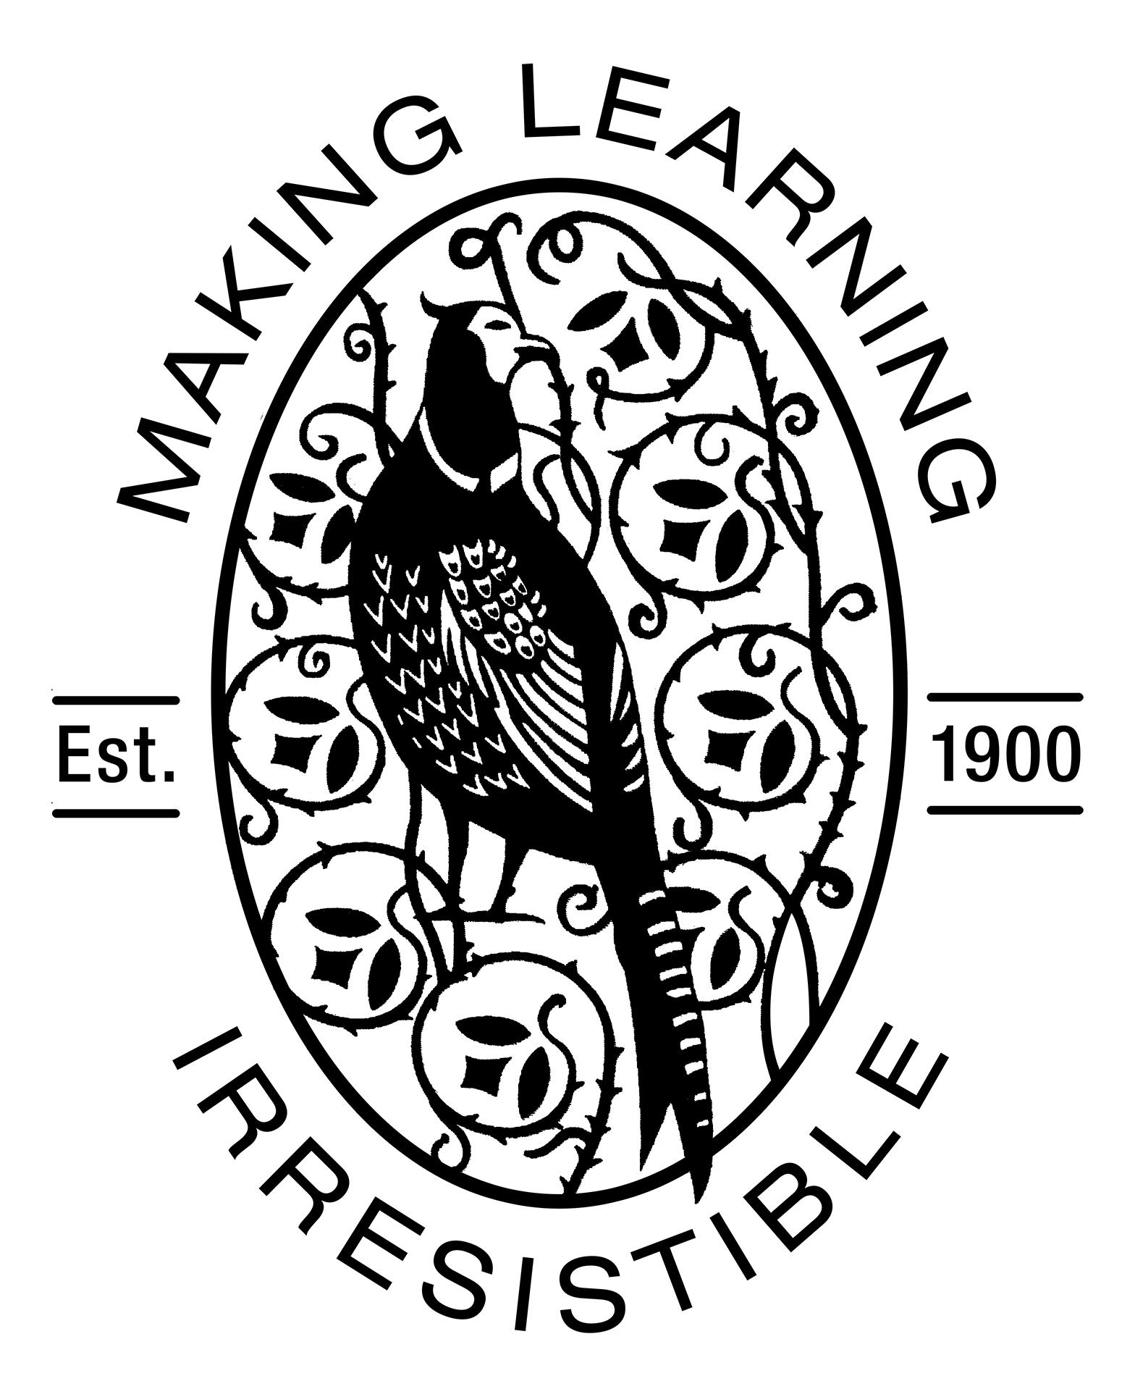

Thank you for taking the time to complete this information with your child. It is designed to help us get to know your child more quickly when they begin school. Please do not feel obliged to answer every question; we can talk about any issues at the Home Visit in September.

This is me and the people who are special to me.

My name is: ............................................. (write your own name)

Please draw you with family and friends (or pets!).

You may wish to write what your child says about their picture.

Playing and Learning

Please tell us about:

The games you like to play:

………………………………………………………………………………………………………………………………………………………………………

What kinds of things do you enjoy doing with your family? (e.g. playing games, painting, walking)

………………………………………………………………………………………………………………………………………………………………………

………………………………………………………………………………………………………………………………………………………………………

Do you take part in any musical activities? (learning an instrument, singing group)

………………………………………………………………………………………………………………………………………………………………………

Do you take part in any other creative activities? (dance, painting, sports)

………………………………………………………………………………………………………………………………………………………………………………

Do you like to use any of these things: DVD/CD player;
computer or tablet; remote controls for TV/hi-fi; remote control toys?

………………………………………………………………………………………………………………………………………………………………………………

Being Independent

Dressing and undressing:

Please tick the box if you can: take socks off put socks on

take shoes off put shoes on

Fasten shoes: with Velcro

with buckles

with laces

take coat off put coat on

Fasten coat: with buttons with zip

I can get dressed or undressed by myself

In the Bathroom:

I can wash my hands by myself.

I can blow my own nose.

I can ask to go to the toilet.

I can use the toilet on my own.

Any support needed? ……………………………………………………………………………………………………………………………………………………

………………………………………………………………………………………………………………………………………………………………………………

……………………………………………………………………………………………………………………………………………………………………….……

Talking, Listening, Understanding

Languages spoken at home are (and by which parent):

……………………………………………………………………………………………………………………………………………………

Other languages understood:

……………………………………………………………………………………………………………………………………………………

Can your family easily understand you when you speak?

……………………………………………………………………………………………………………………………………………………

Can other people easily understand when you speak?

……………………………………………………………………………………………………………………………………………………

Do you ask a lot of questions?

……………………………………………………………………………………………………………………………………………………

Can you carry out requests or follow simple instructions?

……………………………………………………………………………………………………………………………………………………

Are you talkative or quite quiet?

……………………………………………………………………………………………………………………………………………………

Enjoying Stories

At the moment my favourite book is:

……………………………………………………………………………………………………………………………………………………

But I also like:

……………………………………………………………………………………………………………………………………………………

Who reads stories to you in your family?

……………………………………………………………………………………………………………………………………………………

Do you listen to stories on CD?

……………………………………………………………………………………………………………………………………………………

Do you go to the library to borrow or look at books?

……………………………………………………………………………………………………………………………………………………

Do you like acting out stories you know?

……………………………………………………………………………………………………………………………………………………

Do you enjoy songs and rhymes?

………………………………………………………………………………………………………………………………………………………………………………

Here is a picture about my favourite story or rhyme:

You may wish to write what your child says about their picture.

Moods, Feelings and Behaviour

Do you have a favourite toy or comforter?

……………………………………………………………………………………………………………………………………………………

What happens when you get angry or frustrated?

……………………………………………………………………………………………………………………………………………………

Is there anything that worries or frightens you?

……………………………………………………………………………………………………………………………………………………

Do you find it easy to make new friends?

……………………………………………………………………………………………………………………………………………………

Is there anything else you would like to share?

………………………………………………………………………………………………………………………………………………………………………………

………………………………………………………………………………………………………………………………………………………………………………

………………………………………………………………………………………………………………………………………………………………………………

………………………………………………………………………………………………………………………………………………………………………………

Being Active and Healthy

Do you enjoy playing outside?

……………………………………………………………………………………………………………………………………………………

What kinds of things do you like to do when you play outside?

……………………………………………………………………………………………………………………………………………………

Do you take part in any clubs or organised activities? (e.g. swimming)

……………………………………………………………………………………………………………………………………………………

When is your usual bed time?

……………………………………………………………………………………………………………………………………………………

Do you usually sleep well?

……………………………………………………………………………………………………………………………………………………

Is there any health problem that we don’t already know about?
e.g. allergies, bed-wetting, serious illness, hospitalisation etc

……………………………………………………………………………………………………………………………………………………

………………………………………………………………………………………………………………………………………………………………………………

Any involvement with other agencies?
(e.g speech therapist, osteopath, social care etc)

………………………………………………………………………………………………………………………………………………………………………………

………………………………………………………………………………………………………………………………………………………………………………

Thank you for taking the time to complete this information. The booklet and the discussion we have at the home-school visit help us to help your child settle in quickly to the new routines of the Reception year at Morley Memorial. Your involvement as your child’s first educator is very important, and we aim to make the home-school relationship positive and supportive. If you have any particular concerns please let us know.

Make a note of any questions you have and we will do our best to discuss them at the Home Visit.

………………………………………………………………………………………………………………………………………………………………………………

………………………………………………………………………………………………………………………………………………………………………………

………………………………………………………………………………………………………………………………………………………………………………

………………………………………………………………………………………………………………………………………………………………………………

………………………………………………………………………………………………………………………………………………………………………………

Morley Memorial Primary School is committed to safeguarding and promoting the welfare of children. We expect and require all members of the school community to share this commitment.

Morley Memorial Primary School, Blinco Grove, Cambridge CB1 7TX
Telephone - 01223 508 786 Fax – 01223 508 787 e-mail – office@morley.cambs.sch.uk

