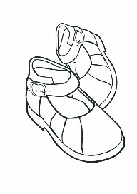

**Sensible shoes**

*Which children can, manage independently.*

*PLEASE NO LACES!*

**Sun hat**

**Named bottle of sun cream**

**Rain coat**



**Named lunch box with drink**

(if having packed lunches)

**Named PE Kit**

T-shirt

Shorts

Plimsolls with Velcro

Jogging top & bottoms

Spare socks

In an easy to open named bag.

(Cloth drawstring type)

**Spare Set of Clothes**

In a separate bag (just in case!)

**Book Bag**

(Available from School Office)

***PLEASE NAME EVERTHING***

***AND KEEP IN SCHOOL EVERY DAY***