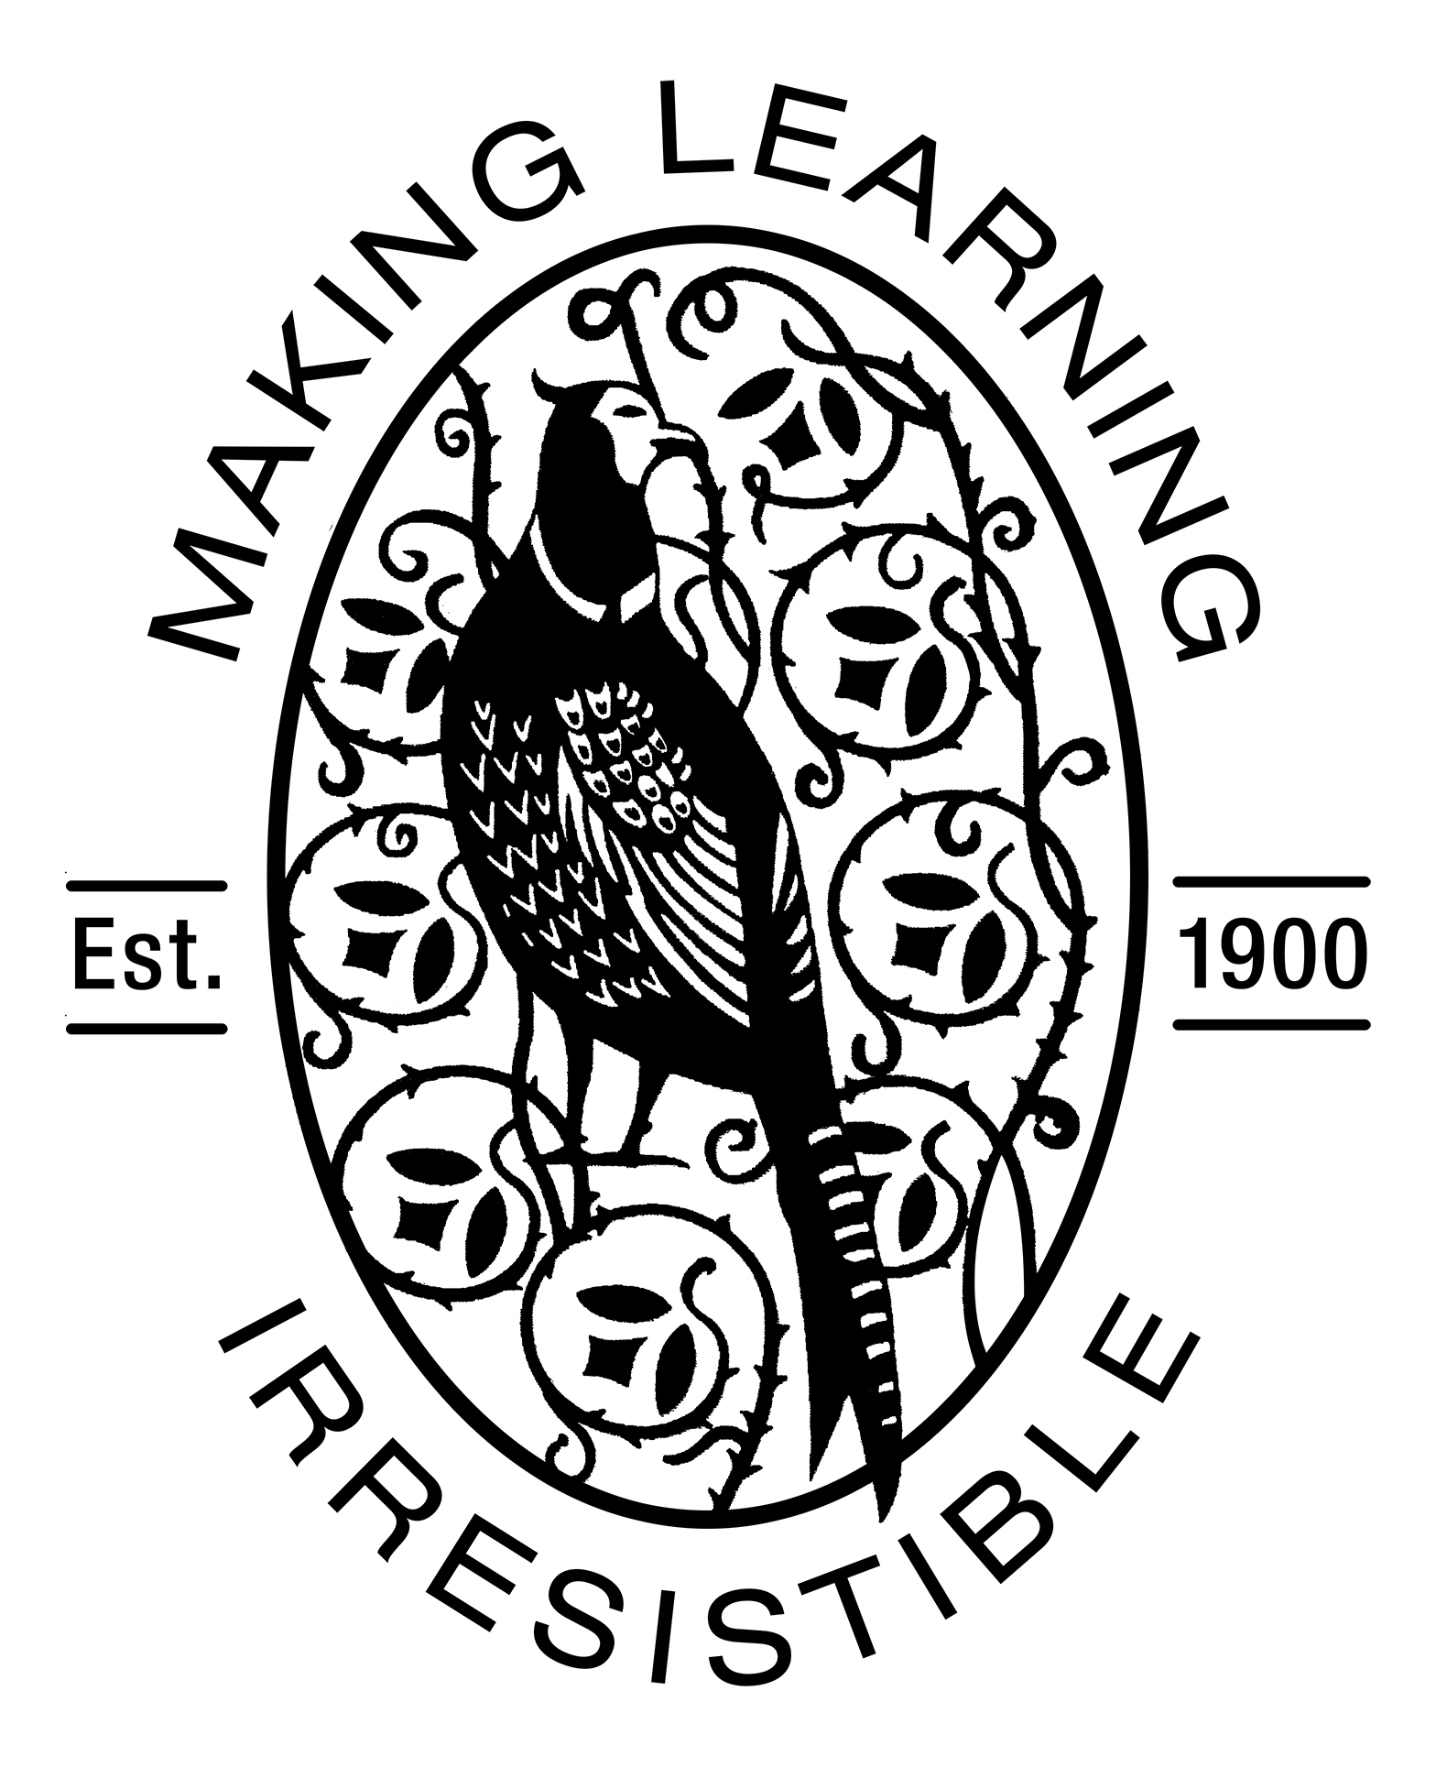
Fax: 01223 508787

Dear Parents

School Letters/Notifications

As you will know, we try very hard to improve the service that we deliver to you and your children by communicating as frequently as possible so that everyone is kept informed.

However, we are all aware that sending written information home can be rather ‘hit and miss’ with letters often going missing on the way!

With this in mind we ask all our families at Morley Memorial to sign up to a service called ParentMail. This enables us to send letters and messages direct to parents by email. We have been using this service successfully for several years now and we are confident that it enables you to receive information from the school in a more reliable and efficient manner.

In order to ensure ParentMail is used effectively we need to collect email addresses and would ask you to complete the form below. Please be assured, the service is registered with the Data Protection Registrar and guarantees that all email addresses will be kept completely private. If you are unable to access emails and wish to opt out of ParentMail please contact the school office.

Yours sincerely,

Nikki Brown
Headteacher

--------------------------------------------------------------------------------------------------------------------------------------
I am able / not able (please amend) to receive school information by email

Parent Name:

Children/s names________________________________ Class_________

My Email address/es______________________________(insert email address/es)

Signature_____________________________ Date______________

