8
Day 1 | Day 2 | Day 3 | Day 4 | Day 5
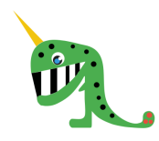  hain  broy  clowp  rawg  crown  dream  blue  oyster | fress  plare  trew  phaig  strain  draw  delay  roots | shorf  gringe  flurst  strulp  farmer  heard  amaze  flute | 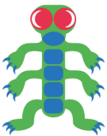  dawt  libe  thropt  scroop  window  tray  quite  gnomes | gloud  chonf  knort  raunk  mountain  shopping  cheerful  whisper

