6
Day 1 | Day 2 | Day 3 | Day 4 | Day 5
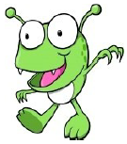  kig  tob  mub  pleg  thin  doll  peep  step | 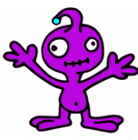  guch  zoit  quorg  usk  stool  bliss  buns  forks | clort  cruss  thulf  varnd  paw  wade  skate  grips | 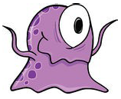  bir  dofe  swike  skeps  sprint  surf  feast  floats | 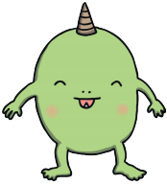  thruff  sprist  gurg  louft  agree  artist  fishing  servings

