4
Day 1 | Day 2 | Day 3 | Day 4 | Day 5
heb  zot  zut  slig  shush  duck  dart  slid | 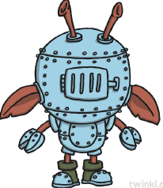  zaff  doop  shoss  ond  steer  cling  mitt  reels | skork  krech  dulf  goomp  see  dine  drake  slight | vor  pabe  blipe  thrilf  stroke  spray  soap  driveway | 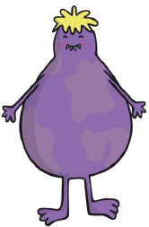  florx  strebs  virn  bauft  sweets  coral  bitten  outline

