Day 1 | Day 2 | Day 3 | Day 4 | Day 5
pob  zub  jop  flum  chill  such  been  snap | 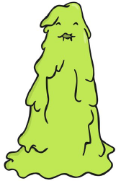  ress  zoid  charb  ids  proof  trick  link  shelf | 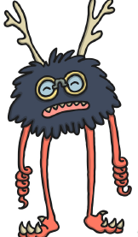  skorp  trath  sulp  loogs  new  dice  slate  grasp | tur  thade  cripe  shremp  spree  toad  round  floats | 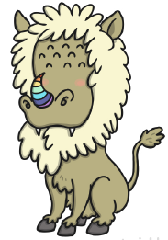  splan  scrisp  mirt  snurst  apart  hotter  tonsils  thousand
3

