Day 1 | Day 2 | Day 3 | Day 4 | Day 5
fam  bep  isk  noz  bash  seek  mess  tank | chot  bock  aff  wong  bang  ma rk  send  moon | 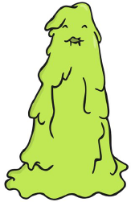  quib  wox  shild  tomp  third  caught  made  sister | 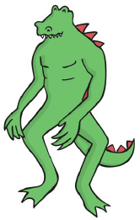  sabe  mouch  vert  jight  burn  away  train  home | simp  strup  phit  zote  firm  driver  member  every

Day 1 | Day 2 | Day 3 | Day 4 | Day 5
tox  bim  vap  ulf  shin  gang  week  chill | geck  chom  tord  thazz  grit  start  best  hooks | blan  steck  hild  quemp  day  slide  newt  phone | voo  jound  terg  fape  blank  trains  strap  scribe | snemp  burst  spron  stroft  rusty  finger  dentist  starling

