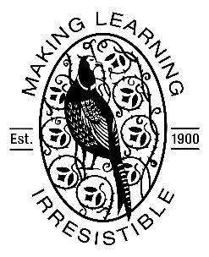

Fax: 01223 508787

E-mail: [office@morley.cambs.sch.uk](mailto:office@morley.cambs.sch.uk)

**Tuesday 19th December 2017**

Dear Parents/Carers,

We are at the end of an exciting first term of Year 5 and are looking forward to our next topic, ‘Were the Vikings vicious?’ We are pleased to have organised a visitor from Gripping History for a whole day on **Friday 11th January**. This will be the third year that Cathy Murphy has visited for an immersive Viking day. In previous years, it has been a memorable day that has really bolstered our understanding in History. We will sail Lego Longships across the North Sea on a floor map and handle replica Viking objects to try and deduce what they tell us about the people that owned them. We’ll play a Viking board game called ‘Hnefltafl’ and examine Viking armoury. The day will end with an exciting (carefully choreographed!) re-enactment of a Viking battle.

On the day, children have the opportunity to dress up as a Viking, *should they wish to*. Attached to this letter are suggestions for outfits and props.

The cost of this visit will be £5 per pupil. As always, the cost is a voluntary one, but if we cannot cover the cost of the visit it may considerably limit future trips and activities. ParentPay will become available for payment when we return to school in January. Please return the reply slip below, regardless of whether you have chosen to pay on ParentPay, by *12th January*.

Thank you,

Amy Rosier and Jack Pullen

bs00439_**bs00439_bs00439_bs00439_bs00439_**

In School Viking Workshop

Name of child: ……………………………………………….

*Please tick the relevant box below:*

I enclose payment of £5

I have paid on ParentPay

Signed: ..................................................................