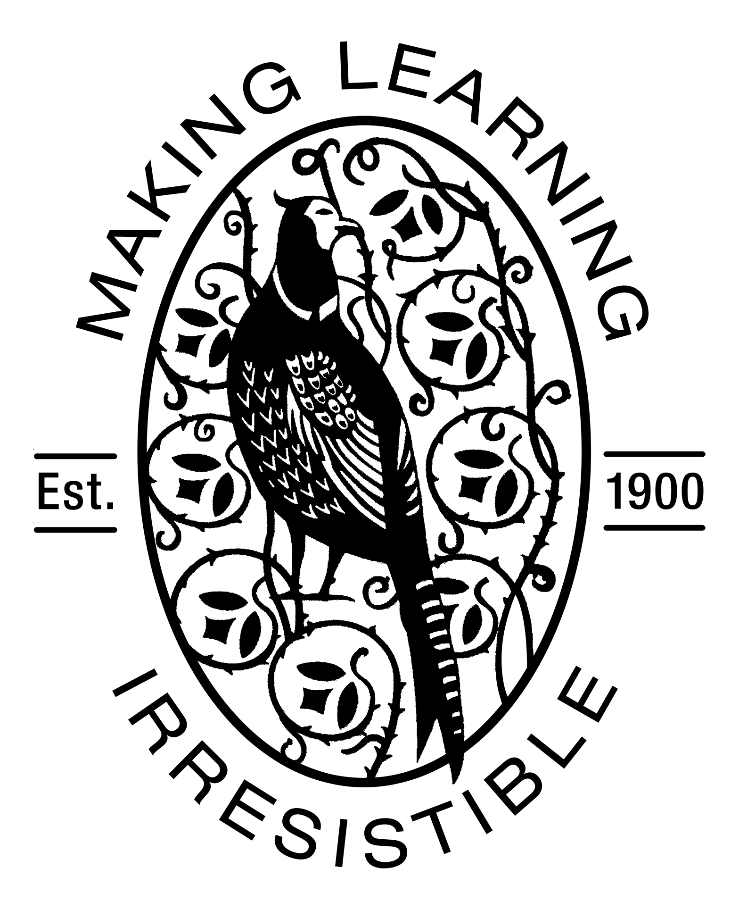

Friday 21st September 2017
Dear Parents,
It has been great to have all the children in together and watching them make new friends. The children have been busy learning classroom routines and getting familiar with all the new resources and activities.
Area | What we have learnt |  | Ideas to support at home
Topic | We have been getting to know each other learning our names. We have also been looking carefully at our faces and creating self-portraits. | Encourage children to talk through the names of other children in their class. Have they made any new friends?
Phonics | We have been learning to listen carefully to the sounds around us, identifying what they might be and whether they are loud or quiet. | Listen to sounds indoors and outdoors and talk about what they are. Encourage children to listen very carefully for the less obvious, quiet sounds – for example birds singing.
Literacy | We have been looking at our names and using them to register ourselves every morning (we find our name and put it in a pot) We have enjoyed retelling ‘We’re Going on a Bear Hunt’ in PE we went on an actual bear hunt – splash sploshing through water and squelch squelching through mud! | Enjoy stories with you child and encourage them to join in with telling them using words and actions.
Mathematics | We have been learning to read and order numbers 1-10. We have had fun putting numbers back into order after they had been muddled up. We have been singing ‘Let’s Count to 20’ to help us learn to count beyond 10. | Encourage your child to recognise numbers around the home, e.g. numbers on clocks, shoes, books, signs.

Here are some key messages for you;
- PE will be on Wednesdays, please ensure named PE kits are on children’s pegs. They should include – a warm top and trousers, sock and PE shoes.
- Children must have their own named cup (not bottle) in school to be kept by the sink and all children need a waterproof coat in school each day.
- If children bring a packed lunch to school they also need to bring a drink, ideally water. Please ensure that they have sufficient healthy food to keep them going through the busy afternoons!

PTO
We also have some requests;
- As part of our topic we will be talking about our community and the people who help us, if you work in this field and can spare some time we would love you to pop in to talk to the children about your job (e.g. police, fire, medical, veterinary, religious leader etc.).
- We will also be talking about families and the different places children in our class and their families might come from. We would like each child to have a photo of their family so we can put it on display. Please also write a brief note of where you and your children are from so we can celebrate diversity in our school.
Thank you for your support,
Ms Del Corso and Mrs Kamanyire

