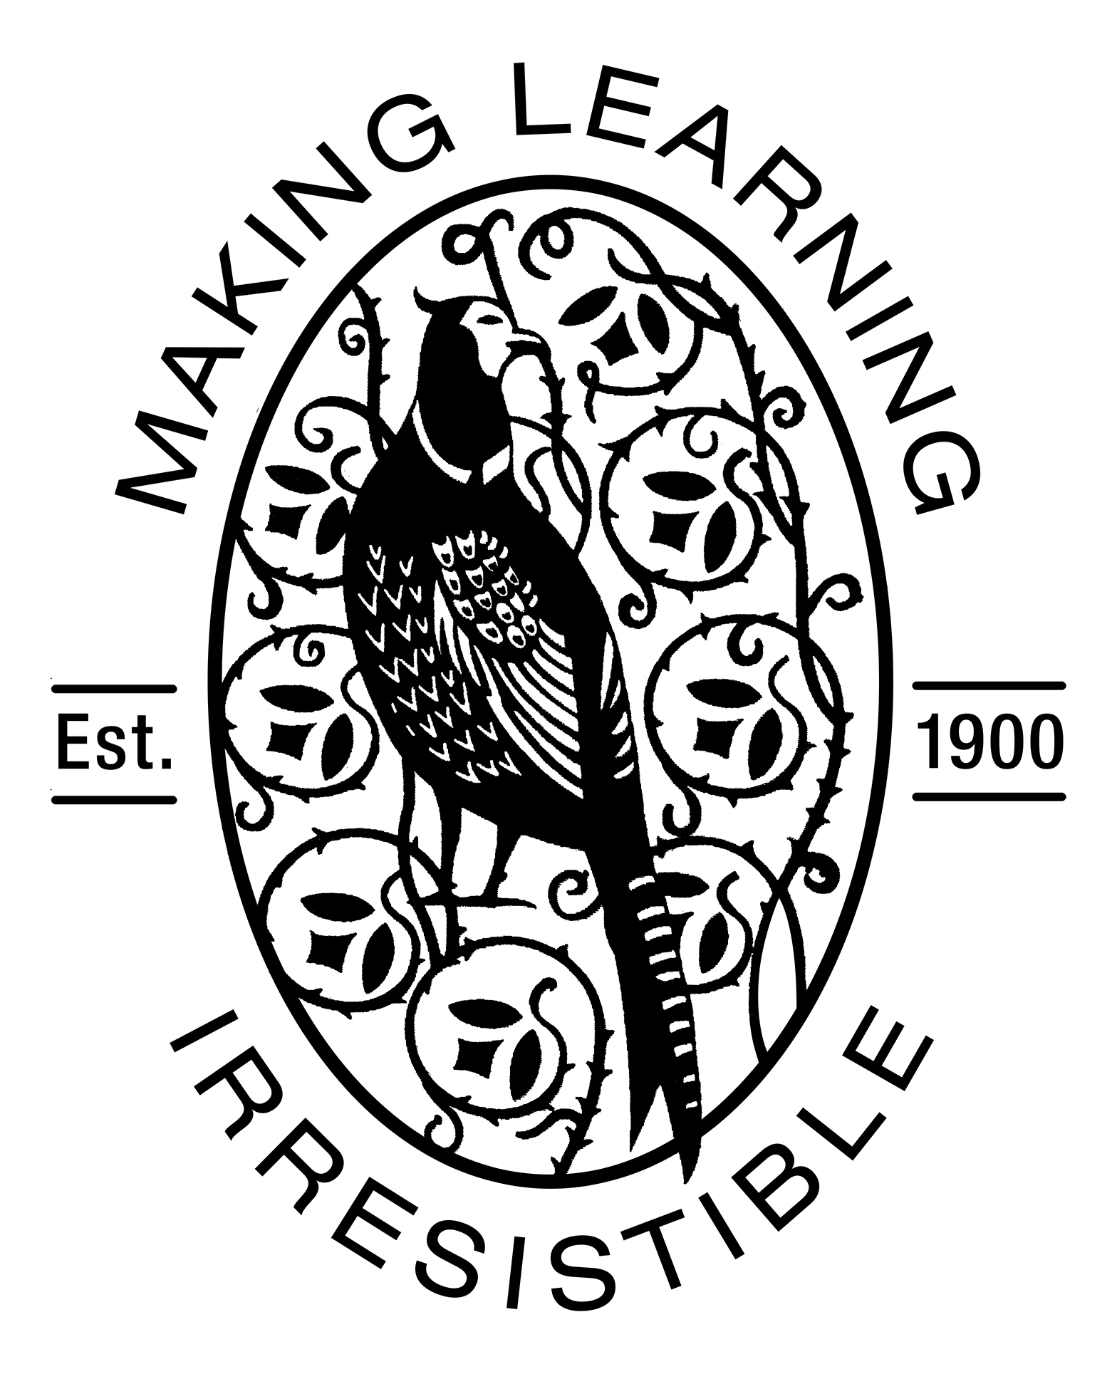

Friday 15th December, 2017
Dear Parents,
Thank you for coming to watch the Christmas Performance this week. We are so very proud of the children for learning the words and actions to the songs and having the confidence to stand in front of such a large audience!

This week has been very busy with Christmas performances (and Christmas lunch!) but we have still managed to find time to talk about the features of cards and to write our own cards. The children have continued to enjoy using the class post office and putting their card writing skills to practice. We have been revising all the letter sounds we know so far (these are the Phase 2 sounds we sent home on the laminated sound mat) Please continue to support your child in hearing these sounds through sound talk and robot arms and also to identify and write them using the sound mat. Encourage your child to write their own cards for friends and family.
Share and Celebrate Together
Don’t forget next Monday and Tuesday we are opening our doors for our “Share and Celebrate Together” sessions, 8:40 – 9:10. Come and look through your child’s learning journey with them, sharing and celebrating their successes so far.

Reading

Books will not be changed on Monday and Tuesday but please ensure that children are coming in with book bags so they can take home any work and cards they might have.

Remember that we will be changing the reading groups next term. The new names will be: Dragon, Monkey, Ox, Tiger and Rooster – five of the animals from the Chinese New Year story. We will also be moving children from different groups and so your child might be reading on a different day.
To help us with this please can you leave reading books in their bags every day for the first week back.
It is great to see so many children have been using ‘Teach Your Monster to Read’ at home and to also see how this supports their learning in school. If you have any questions about this resource or simply need a new log-in please speak to your class teacher. It really is a fantastic FREE resource so please do encourage your child to use it.

PTO

PE Kits
All PE kits have been sent home this week, if not already. Before you send them back at the start of next term please take the opportunity to check that they are complete and that they still fit (especially shoes!) We have noticed children do not have PE clothes suitable for the colder weather. Every child should have a t-shirt, long and warm jogging bottoms, a long sleeved sweatshirt and suitable footwear – trainers or plimsolls.

We will also be sending home spare clothes bags, again please check that these are complete and that they still fit. It is important that all children have a spare set of clothes – it is not solely for toileting accidents but also over vigorous water play and mud accidents!

Time Machine
Our topic next term is ‘Time Machine’. We will be developing our investigation skills and learning about the past, present and future. We will explore how time is measured – hours, days, months and years focusing initially on the New Year. Children will start to write a weekly diary entry. Later in the term will be asking for children to bring in artefacts from home – these do not have to be treasured family heirlooms (in fact don’t send those in!) but something that looks different to what is in use today – the first mobile phones and cassette tapes always raise eyebrows, and make us feel ancient!

Finally we would all like to take this opportunity to thank you for your support and wish you all a relaxing holiday season.
Thank you!
From the Early Years team – Mrs Kamanyire, Ms Del Corso, Mrs McInerney, Chara, Beth and Anna

